**SOIL FARMING AGENT**

NAME: Amala Shrivastava

**INDEX**

|  |  |  |
| --- | --- | --- |
| SL NO | CONTENT | PAGE NO |
| 1. | Introduction | 3 |
| 2. | Web application  Architecture  components | 4-5 |
| 3. | Testing of website | 6 |
| 4. | System modules | 7-11 |
| 5. | Deploying the website | 12 |

**INTRODUCTION**

Soil is a crucial component in agriculture. There are various types of soil. Different sorts of crops thrive on different types of soils, and each type of soil has its own set of characteristics. To understand which crops grow best in which soil types, we need to grasp the traits and characteristics of distinct soil types. The proposed application admin would update the information in the portal and crop/seed distributor details with the help of soil and crop specialists. These soil and distributor details can be viewed by the user.

**BENEFITS**:

* Anyone who is interested in farming can learn about the various types of soils the types of crops cultivated in them and the seller of those crops.
* Get the maximum amount of details in one location
* Get different rates for same type of crop through various dealer.
* Single dealer selling various crops.
* Direct contact with seller without middle-man which provides economical advantage.

**WEB APPLICATION ARCHITECTURE COMPONENTS**

Web application architecture works on various components. These components can be divided into two areas.

**1. User Interface App Components:**As the name suggests this category is much more related to the user interface/experience. In this category, the role of the web page is related to the display, dashboards, logs, notifications, statistics, configuration settings, etc and it has nothing to do with the functionality or working of the web application.

**2. Structural Components:**This category is mainly concerned with the functionality of the web application with which a user interacts, the control, and the database storage. As the name suggests it is much more about the structural part of the web application. This structural part comprises…

* The web browser or client
* The web application server
* The database server

**Web Application Three Tier Architecture Layers**

Web application architectural patterns are separated into many different layers or tiers which is called Multi- or Three-Tier Architecture. You can easily replace and upgrade each layer independently.

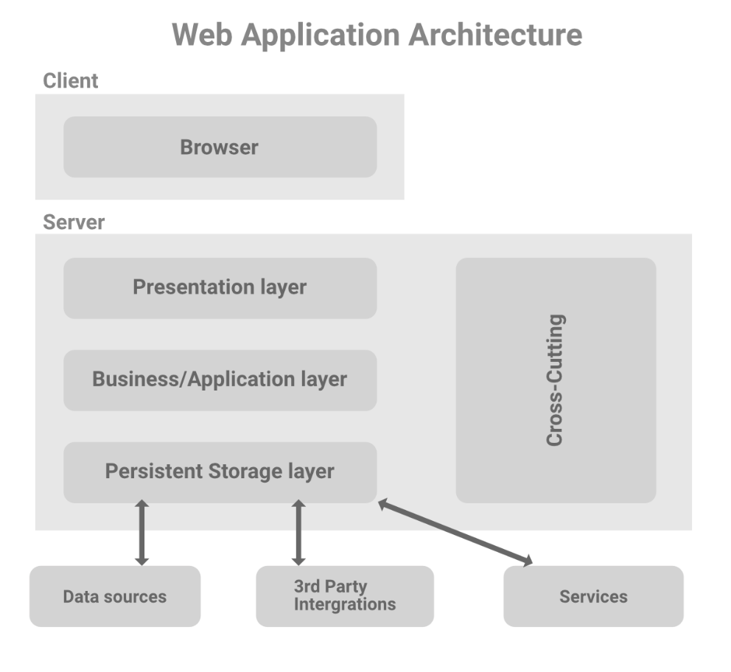

**Presentation Layer:**This layer is accessible to the client via a browser and it includes user interface components and UI process components. As we have already discussed that these UI components are built with HTML, CSS, and JavaScript (and its frameworks or library) where each of them plays a different role in building the user interface.

**Business Layer:**It is also referred to as a Business Logic or Domain Logic or Application Layer. It accepts the user’s request from the browser, processes it, and regulates the routes through which the data will be accessed. The whole workflow is encoded in this layer. You can take the example of entering the soil and crop details on the website. Admin will go through a sequence of events to enter the details and the whole workflow will be taken care of by the business logic.

**Persistence Layer:**It is also referred to as a storage or data access layer. This layer collects all the data calls and provides access to the persistent storage of an application. The business layer is closely attached to the persistence layer, so the logic knows which database to talk to and the process of retrieving data becomes more optimized. A server and a database management system software exist in data storage infrastructure which is used to communicate with the database itself, applications, and user interfaces to retrieve data and parse it. You can store the data in hardware servers or in the cloud.

## **TESTING OF WEBSITE**

## **1. Functionality Testing**

**Functionality Testing of a Website** is a process that includes several testing parameters like user interface, APIs, database testing, security testing, client and server testing and basic website functionalities. Functional testing is very convenient and it allows users to perform both manual and automated testing. It is performed to test the functionalities of each feature on the website. **All the links in the website are tested and ensured that there are no broken links.**

## **2. Usability testing**:

[Usability Testing](https://www.guru99.com/usability-testing-tutorial.html) has now become a vital part of any web based project. It can be **carried out by testers** like you **or a small focus group** similar to the target audience of the web application. **The provided application is tested for the button and links usability and visibility.**

## **3. Compatibility testing.**

Compatibility tests ensures that your web application displays correctly across different devices**. The website is tested and displays correctly across browsers**.

**4. Performance Testing:**

This will ensure your site works under all loads**. Website application response times at different connection speeds is tested and works fine**.

## **5. Security testing:**

[Security Testing](https://www.guru99.com/what-is-security-testing.html) is vital for e-commerce website that store sensitive customer information like credit cards. **Authorisation of the admin is compulsory he is the one who administrates the website.**

## **SYSTEM MODULES:**

The two different modules present in the website are:

1. Admin Module
2. User Module

**1. ADMIN MODULE**:

* The admin has been given a secret key using which he/she can login with authentication.
* There is only one admin considered in this program with the credentials as name is ‘anne’ password as ‘23456’ and key ‘340’.
* The admin can not only view the user pages and but add crops or soil to the website.

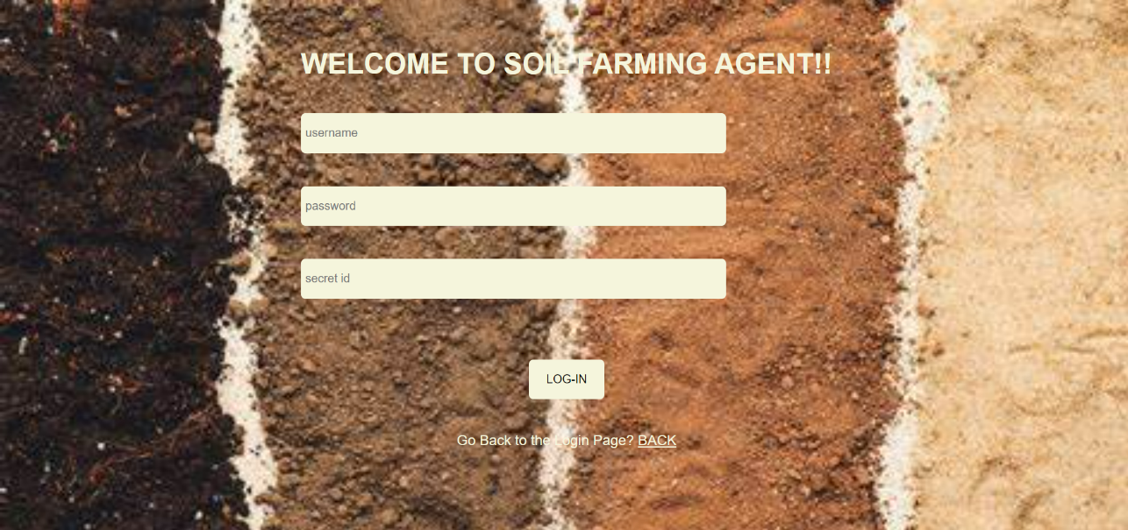

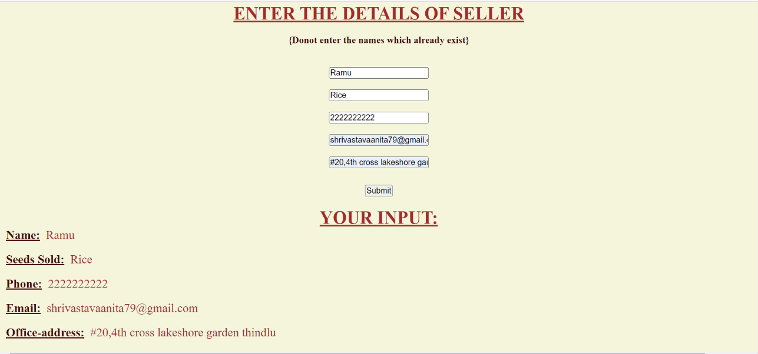

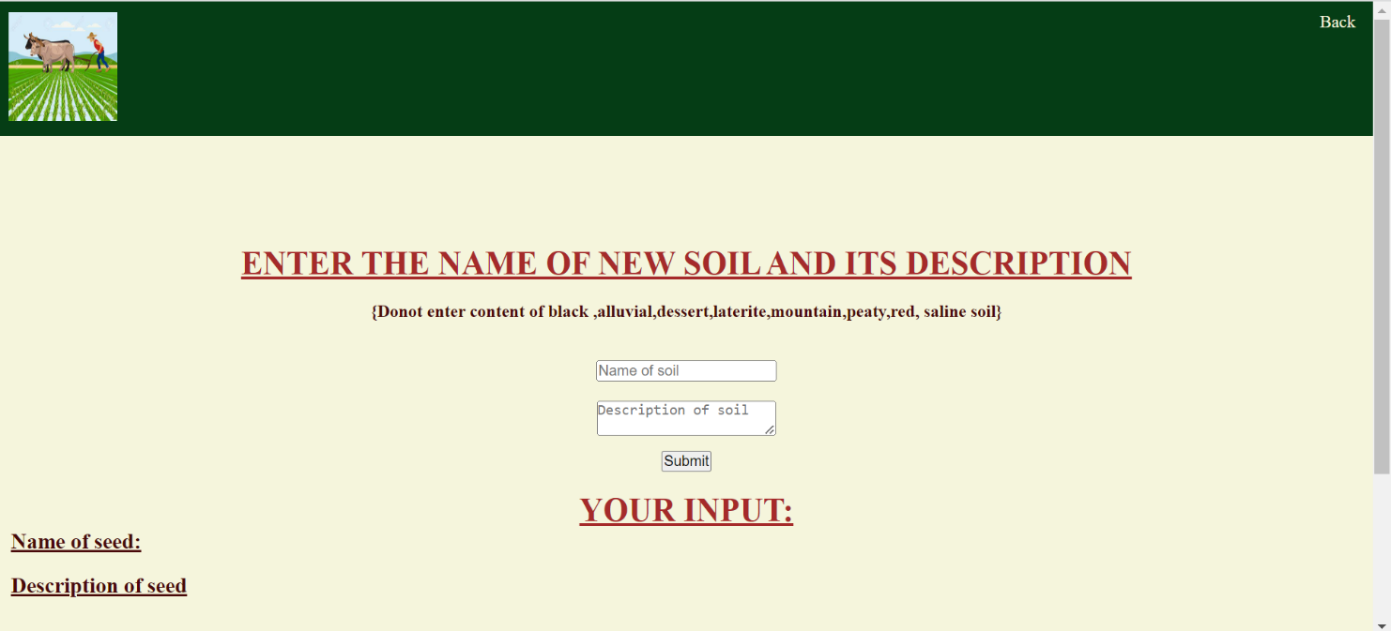

**2. USER MODULE**:

* The user who wants to use the website must login to the website or sign up if new.
* The user can see the various types of soil and their properties, the types of crops to be cultivated there .
* The user can also see the details of various sellers of crops and contact them.

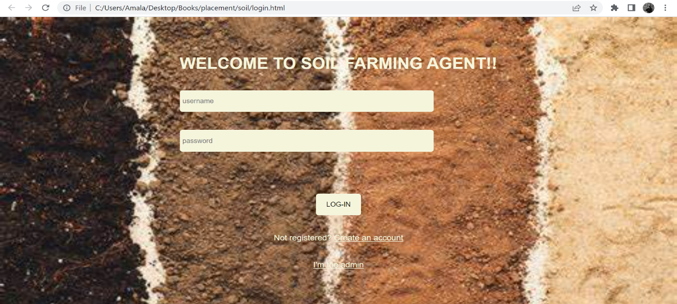

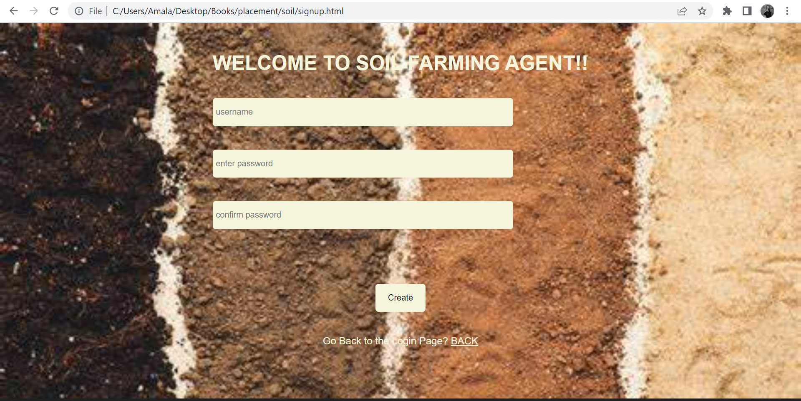

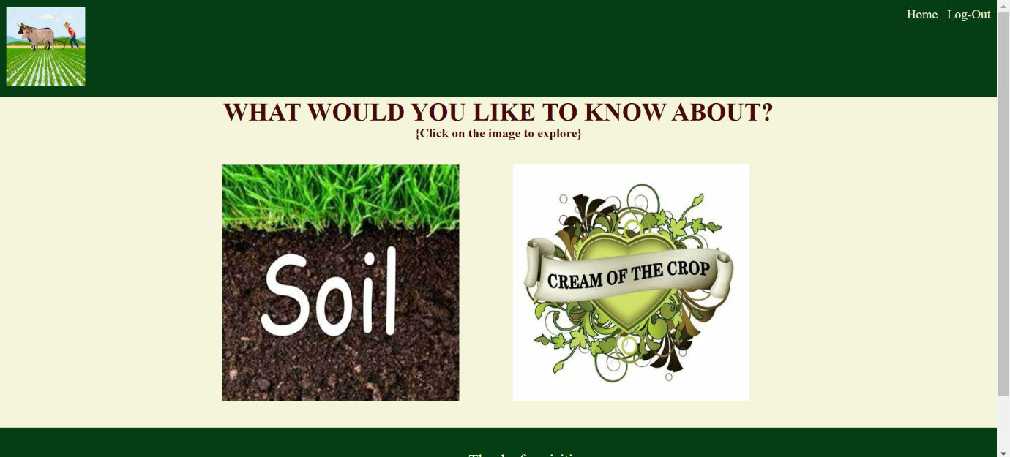

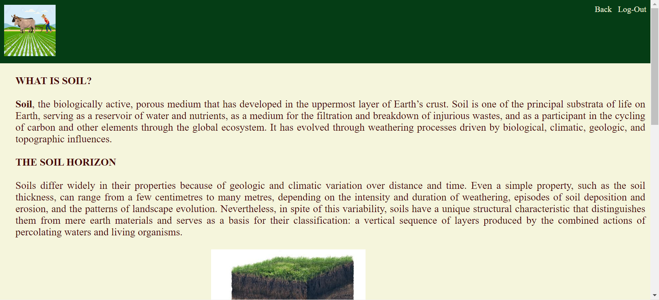

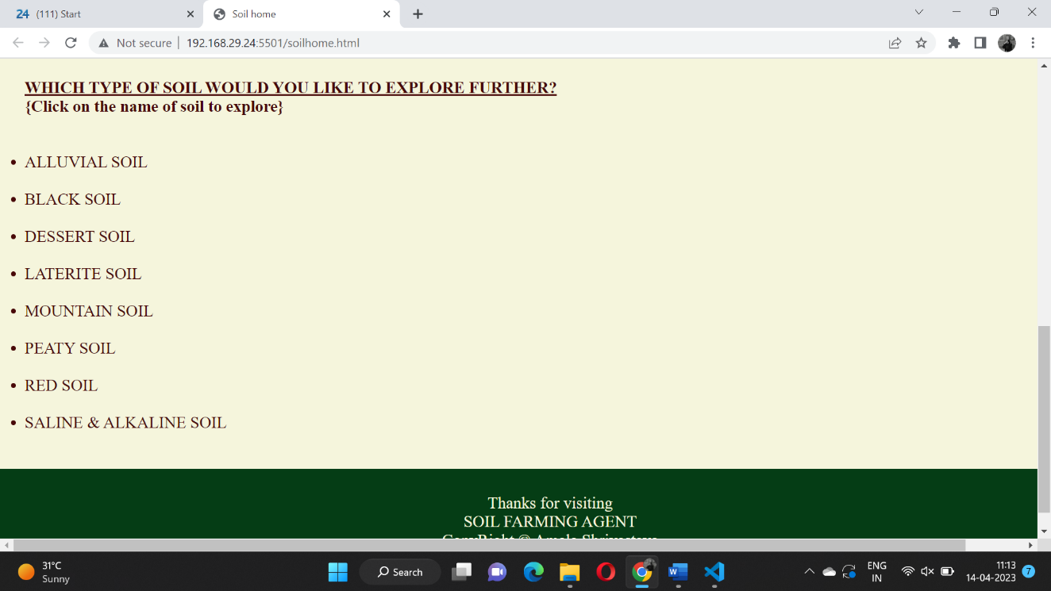

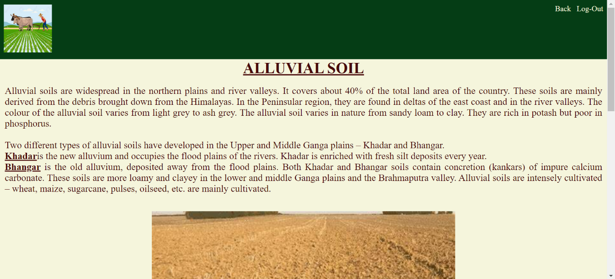

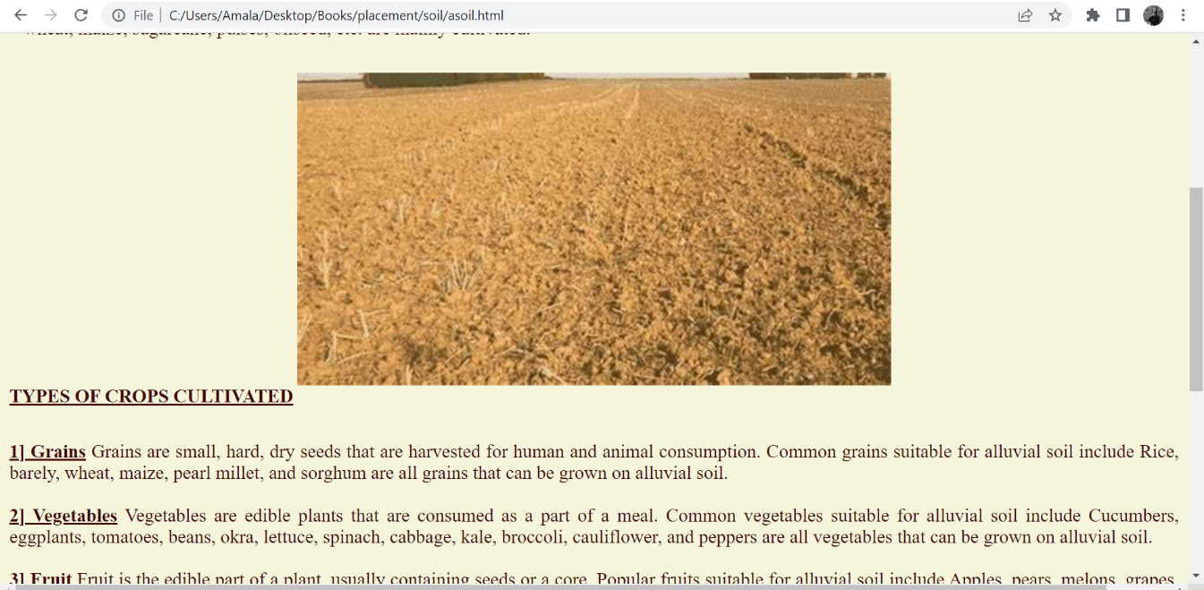

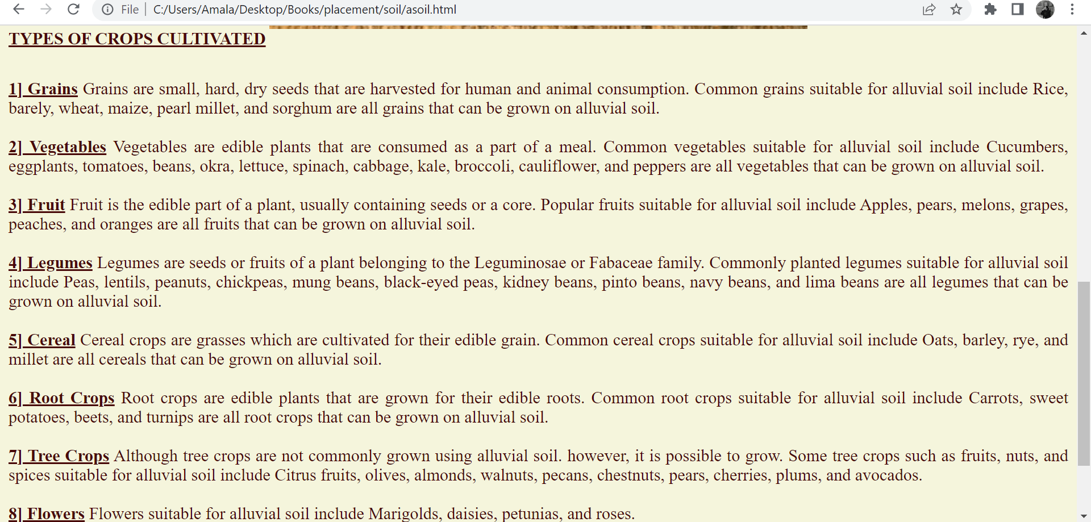

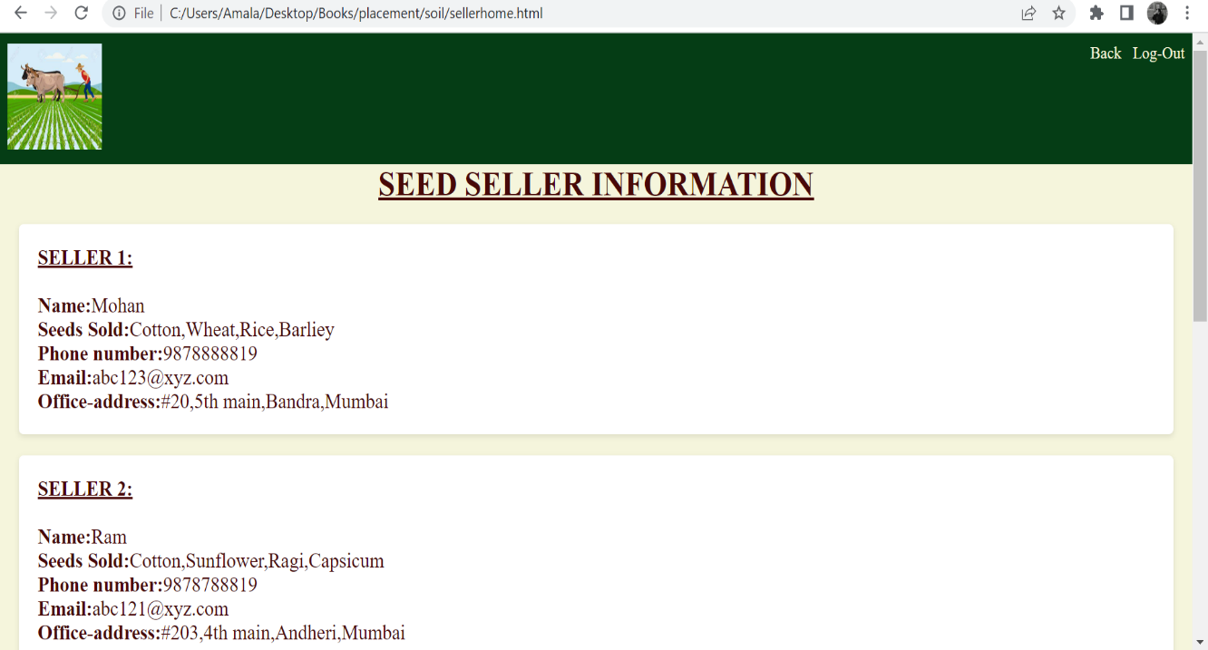

**DEPLOYING THE WEBSITE**

**Step 1: PREPARATION**

The three general scenarios of a website deployment is:

1. The client has nothing (i.e. this is their first website)
2. The client already has hosting and you will be deploying the site on their server
3. The client already has hosting but you will be moving to a new server.

### **Step 2: SET UP DNS RECORDS**

Create yourself an A record (the address record that maps a domain name to the IP address of the server) or subdomain record for a live development site such as dev.domainname.com. Point this subdomain to the IP address of the new server.

### **Step 3: SET UP A LIVE TESTING SITE**

It’s now time to see if the site works on the live server environment. A practice I recommend doing is setting up a subdomain URL prior to officially deploying the site. Something like dev.domainname.com which will eventually be on domainname.com.

### **Step 4: SET UP EMAIL ACCOUNTS**

The next step to consider if we are moving the email of client? If their email is currently in the same hosting account as the old website, then you will probably be moving mail to the new server. If so, collect all email account addresses and set up the exact same accounts on the new server.

### **Step 5: BACKUP AND GO LIVE**

Even if you are hosting on a new server, take a full backup including any databases of the old website, as you never know when you might need something. OK, all set to go live.